IBSIG Spotlight Form
Spotlight Instructions  Please complete the following questions (the best you can) and return by email to  publicrelations@ibsig.ca  Attach a high resolution photo to your email to complete your submission.  Your completed Spotlight submission will be reviewed and will be posted on the IBSIG website here: http://ibsig.ca/member-spotlights/ | Photo Specification  - Photo of Waist-up  - “Business Quality” photo  - High resolution JPG (file will be over 2 mb)  - Well lit  - Smile!  - Stand against a neutral backdrop  - 2 ft around subject  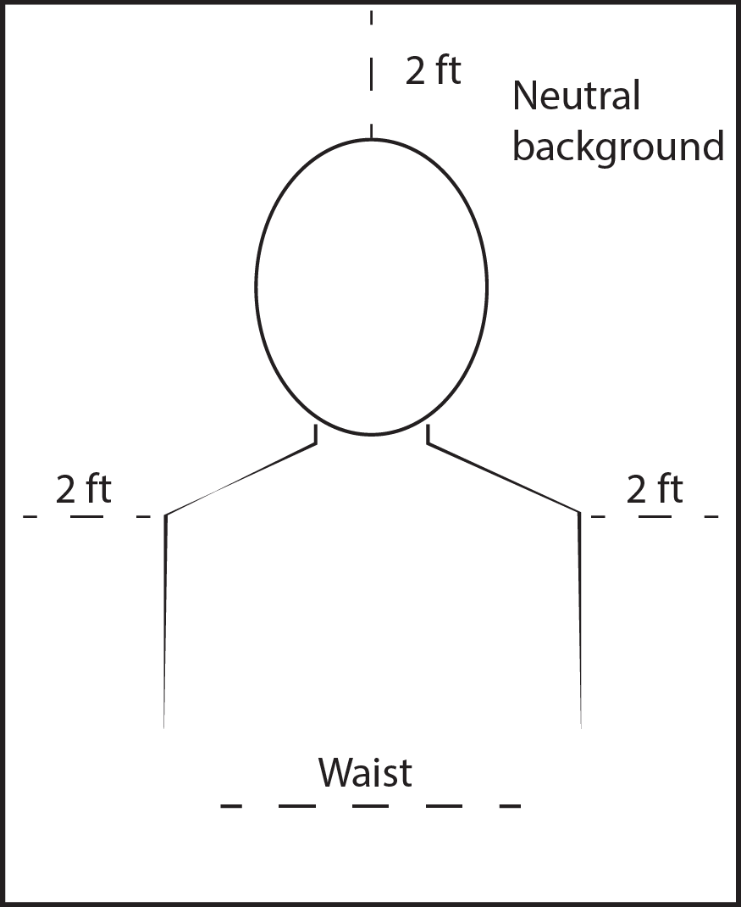

Participation in the Faces of EntrepreNURSEship Poster
Would you like to be considered for the next “Faces of EntrepreNURSEship” poster (free advertising)? Your high resolution photo from the Spotlight submission will be adapted for use in the poster. You would receive several copies of the poster for your promotional use.
Answer: Y/N

CONTACT INFORMATION
Please provide your contact information for the webmaster to contact you if any questions about this submission.
Name:
Phone:
Email:

Spotlight Title

What do you wish to call your Spotlight? (Please supply a catchy “title” to your spotlight. For ideas, visit the other spotlights on the website: http://ibsig.ca/member-spotlights)
Answer:

Spotlight Questions

General Questions & Getting to Know You
(Answer what you are comfortable providing)

1. What is your Business name?
Answer:

2. What is your website address?
Answer:

3. What are your social media platforms?
Answer:
FB page:
Youtube:
LinkedIn:
Instagram:

4. What do you do for fun (hobbies/interests as a break from work)?
Answer:

5. What quote or Role Model inspires you? Example: "You become what you think"-Margaret Thatcher, Iron Lady, Britain's Prime Minister 1979-1990)
Answer:

Your back story!
(Answer as much as you can and are comfortable providing)

6. When did you become an RPN and what was your education route?
Answer:

7. What led you to become an EntrepreNURSE (an RPN running an independent business)?
Answer:

8. What is the focus of the business; what treatment do you provide?
Answer:

9. How long have you been in Business?
Answer:

10. What challenges have you faced?
Answer:

11. What have been your rewards as an EntrepreNURSE?
Answer:

12. What have you learned along the way that you would like to share with other RPNs?
Answer:

13. How has IBSIG helped?
Answer:

14. What does your business future hold?
Answer:

